SPECIAL AUDITION PROCESS TO THE HUNGARIAN DANCE ACADEMY IN 2020

To avoid travel and personal contacts during the Covid-19 pandemic applicants to the Dance Artist training program should audition by sending their recordings by 15 June 2020.

CLASSICAL BALLET

The application material needs to include the followings:

- Student application form – available at: http://mte.eu/en/admission-2020
- Photos as required on the application form (face and full figure)
- The recording the classical ballet training as provided by HDA)
- A recording from one’s previous studies (possibly the most up-to-date one) of stage variation (pointe work), or part of a play, respectively a recording taken in the ballet studio (max. 15 minutes from the exercises of centre, jump/allegro and pointe work, with no editing within one exercise
- All further attachements as described on the Student application form.
Load all to …………….
or send it by wetransfer.com to: contact@mte.eu
Wear: girls in tights, sleeveless or cap-sleeve or camisole leotard, balletshoes / pointe shoes
boys: leotard or skinny t-shirt and tights, ballet shoes

The camera for the recording described in point „c” should be positioned slightly athwart to the front, almost aside. (As seen in the picture attached).
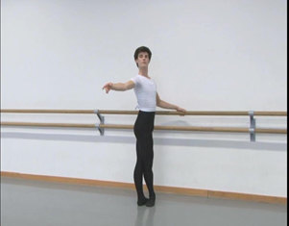 | Begin the recording with introducing yourself: your name, age, present school and the name of your balletmaster.  Then a full-figure face-to face and a side-face shot is required to reveal your posture.  Following these you can begin the exercises at the barre: each exercise must be performed to one side, i.e. plié to the right, battement tendu to the left, battement tendu jeté to the right etc.

