SPECIAL AUDITION PROCESS TO THE HUNGARIAN DANCE ACADEMY IN 2020

To avoid travel and personal contacts during the Covid-19 pandemic applicants to the Dance Artist training program should audition by sending their recordings by 20 June 2020.

CLASSICAL BALLET

The application material needs to include the followings:

- Student application form – available at: http://mte.eu/en/admission-2020
- Photos as required on the application form (face and full figure)
- The recording the classical ballet training as provided by HDA) – availablet at:
https://drive.google.com/drive/folders/1v5fIuUywJX6IHs5HTE0knO2QVnf7nEJt?usp=sharing
Max. 15 minutes from the exercises of centre, jump/allegro and pointe work, with no editing within one exercise
- A recording from one’s previous studies (possibly the most up-to-date one) of stage variation (pointe work), or part of a play, respectively a recording taken in the ballet studio
- All further attachements as described on the Student application form.
Send all by wetransfer.com to: contact@mte.eu
Wear: girls: in tights, sleeveless or cap-sleeve or camisole leotard, balletshoes / pointe shoes
boys: leotard or skinny t-shirt and tights, ballet shoes

The camera for the recording described in point „c” should be positioned slightly athwart to the front, almost aside. (As seen in the picture attached).
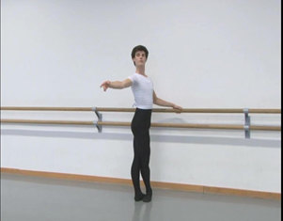 | Begin the recording with introducing yourself: your name, age, present school and the name of your balletmaster.  Then a full-figure face-to face and a side-face shot is required to reveal your posture.  Following these you can begin the exercises at the barre: each exercise must be performed to one side, i.e. plié to the right, battement tendu to the left, battement tendu jeté to the right etc.

Applicant needs to be aged 15 to 18. (Younger applicants contact our staff for live audition.)
International students are placed according to their knowledge and skills.

Those admitted need to take care of their general education in their home countries or by distance learning.
Tuition fee: 2500 EUR / semester

