SPECIAL AUDITION PROCESS TO THE HUNGARIAN DANCE ACADEMY IN 2020

To avoid travel and personal contacts during the Covid-19 pandemic applicants to the Dance Artist training program should audition by sending their recordings by 20 June 2020.

MODERN / CONTEMPORARY
Application is only possible to the new class starting in September 2020.

The application material needs to include the followings:

- Student application form – available at: http://mte.eu/en/admission-2020
- Photos as required on the application form (face and full figure)
The recording the basic classical ballet as well as modern/contemporary exercises as provided by HDA – availablet at: https://drive.google.com/drive/folders/1jA6M6EeE0MR51-IbZe_U3PIW950g_596?usp=sharing
Max. 15 minutes, with no editing within one exercise
- A recording of a max. 2 minutes choreography chosen and performed by the applicant; can be taken from a recent performance or from a recording taken in the ballet studio
- All further attachements as described on the Student application form.
Send all by wetransfer.com to: contact@mte.eu
Wear:
girls: in tights, sleeveless or cap-sleeve or camisole leotard, soft ballet shoes for the ballet exercices, socks or barefoot for the modern/contemporary part
boys: leotard or skinny t-shirt and tights, soft ballet shoes for the ballet exercices, socks or barefoot
for the modern/contemporary part

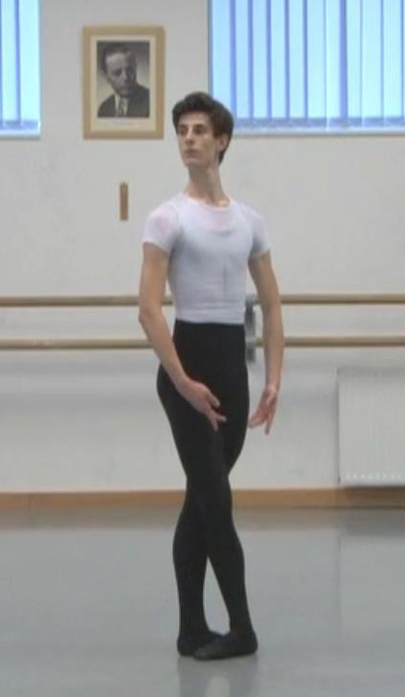 | The camera for the recording described in point „c” should be positioned athwart to the front, almost in the middle.  Begin the recording with introducing yourself: your name, age, present school and the name of your balletmaster and further teachers. Then a full-figure face-to face and a side-face shot is required to reveal your posture. Following these you can begin the exercises. | 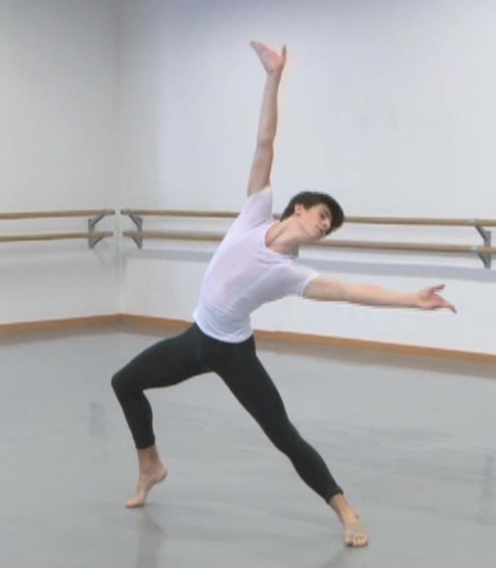
Regarding ballet: each exercise must be performed to one side, i.e. plié to the right, battement tendu to the left, battement tendu jeté to the right etc.

Applicant needs to be aged 14-16.
The professional, full time training consists of five years: two years preparatory + three years bachelor degree program.

Those admitted need to take care of their general education in their home countries or by distance learning.
Tuition fee: 2500 EUR / semester

