Foreign Language Requirements

for International BA Students Starting their Studies at the H.D.U.

from September 2023 on

The foreign language criterion test is a prerequisite for the pre-degree certificate for students in the BA degree courses.

The foreign language requirement is considered to be met if the student can provide evidence of the following:

* at least CEFR1 level B1 language examination certificate in English (as the language of tuition is English)
* studying in an English speaking country for one semester in the framework of the Erasmus programme, with supporting documents

Otherwise, the student must take and pass the foreign language criterion test.

**Criterion test:**

Language: English

Level: CEFR B1

Date & Time: To be announced each semester.

The examination can be taken without having completed the language course announced at the H.D.U.

Completion: by the last semester.

The written and oral parts together measure the four basic skills (reading comprehension, listening comprehension, writing & speaking).

H.D.U. also offers an optional language course called *PEPM-NYV A1 English* in preparation for B1 level.

Course time (twice a week): Tuesday and Friday

Max. number of participants: 16/ group

Deadline for applications: early September of each academic year.

First class & diagnostic test in 2024: 3 September

Education Authority Accreditation Centre for Foreign Language Examinations in Hungary:

<https://nyak.oh.gov.hu/default-eng.asp>

For your information, see the comparison of certain English language examinations’ B1 level scores below.

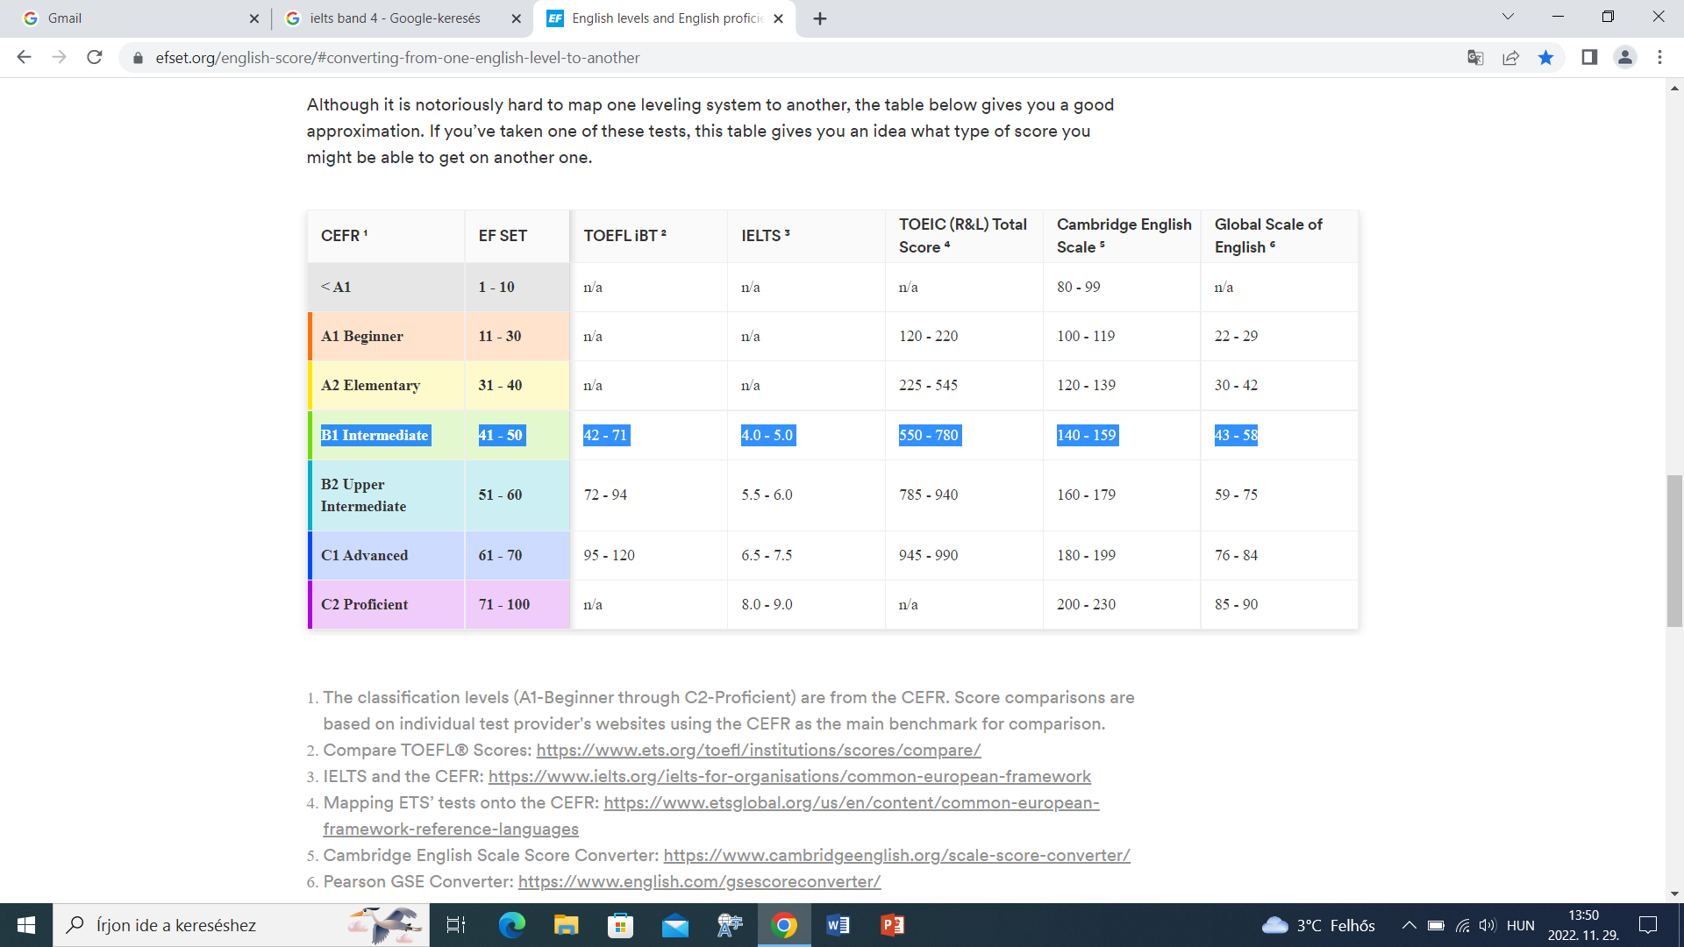

To assess your language level, visit: <https://www.efset.org/english-certificate/>

However, an official, international language examination certificate presented to the Registrar’s Office of the HDU is needed to be exempted from the criterion examination.

Another chart to compare the B1 level scores of English language exams:

### B1

[Cambridge English Key](https://www.examenglish.com/KET/index.php) 140-150

Cambridge English Preliminary ([PET](https://www.examenglish.com/PET/index.html)) 130-159

[B1 Business Preliminary](https://www.examenglish.com/BEC/BEC_Preliminary.html)

[IELTS](https://www.examenglish.com/IELTS/index.html) 4-5

[TOEFL iBT](https://www.examenglish.com/TOEFL/index.html) 42-71

[TOEIC Listening & Reading](https://www.examenglish.com/TOEIC/toeic_listening_and_reading.htm) 550

Both are needed

[TOEIC Speaking & Writing](https://www.examenglish.com/TOEIC/toeic_speaking_and_writing.htm) 240

[PTE General](https://www.examenglish.com/PTE/PTE_General.htm) Level 2

[PTE Academic](https://www.examenglish.com/PTE/PTE_Academic.htm) 43-58

[Trinity ISE I](https://www.examenglish.com/Trinity/ise_1.htm)

In case you have questions regarding the English exams or courses, feel free to contact:

Csilla Sebők: [sebok.csilla@mte.eu](mailto:sebok.csilla@mte.eu)

Nikolett Áder: [nikolett.ader@mte.eu](mailto:nikolett.ader@mte.eu)

Dr. Agota Tongori: [tongori.agota@mte.eu](mailto:tongori.agota@mte.eu)